ECE 279: Performance Evaluation

Assignment #1:
Computer System Simulation Report

Department: ECE
Name: XXX
Perm#: XXXX
Date: 11/25/2013

Contents

A. Objective of the Performance Evaluation Study 3
B. Simulation Model 3
C. Evaluation of the Simulation Results 4
- Average time from arrival of a job to its completion. 4
- Utilization of the devices 5
- Average number of jobs queued for memory 6
- Average number of jobs in the CPU and disks subsystem 9
- Proper length of simulation time 10
- Memory expansion 15
- CPU improvement 17
- Disk1 improvement 17
D. Summary of Recommendations 18

Appendix A: Program Code 19
Appendix B: Output Samples 33

- Objective of the Performance Evaluation Study

The first purpose of this study is to examine the performance of the computer system with different arrival rate (ranging from 1 to 10 jobs per second). The second one is to evaluate the improvement of the performance of the system with improved devices or expanded memory respectively.

Specifically, we evaluate the average time from arrival of a job to its completion, utilization of the devices, average number of jobs queued for memory and jobs in the CPU and disks subsystem. After the collection and analysis of the data above, we identify the bottleneck of the system, and make recommendations, to the manager of the computer installation, about improvements to the CPU, the peripherals, or expansion of the main memory to 2 Gbytes. We also analyze and determine the proper period of simulation time.

- Simulation Model

This is a discrete event simulation of a computer system. There are four kinds of events: job arrival, end of processing, end of transfer on disk1 and end of transfer on disk2. An event list is used to keep records of all the events in the order of occurrence time. The data of each node in the list include the occurrence time, the type of the event and the arrival time of the job corresponding to this event. A queue structure is applied to model the queue of jobs waiting for each device and memory. Each node of the queue records when the job arrives at the queue and how long it waits here.

The computer system contains a CPU, memory, a magnetic disk drive, and an optical disk. The original memory is 1 Gbyte. The operating system needs 250 Mbytes of memory, and each arriving job requires 200 Mbytes of memory. So there are at most 3 jobs in the memory anytime. The arrival of jobs is a Poisson process, and the arrival rate is 1, 2, 3,…, 10 jobs per second at each simulation time. Jobs waiting for memory impose no load on the CPU. Once a job has memory, it queues for access to the CPU. A job leaving the CPU goes to the magnetic disk with probability 0.7, to optical disk with probability 0.2, and leaves the system with probability 0.1. The initial service times at each device are exponentially distributed with means of 0.01, 0.02, and 0.04 seconds for the CPU, the magnetic disk, and the optical disk, respectively.

C. Evaluation of the simulation results

Note: the simulation results of parts 1~4 are based on the following system: memory is 1 Gbyte; simulation time is 300 seconds; mean service times of the CPU, the magnetic disk, and the optical disk are 0.01, 0.02 and 0.04 seconds, respectively.

- Average time from arrival of a job to its completion.
As shown in Table 1, the average time from arrival of a job to its completion is listed in row E(x), when λ ranges from 1 to 10.

Student’s t test is used to determine error in estimate of mean as below:
p(t)=0.05, which means the probability that true expectation E(X) lies above confidence interval;
1-p(t)=0.95, which means the probability that true expectation does not lie above confidence interval;
1-2p(t)=0.9, which means the probability that true expectation lies within confidence interval.
So t=1.833; f=n-1;δ=|E(X)-E(x)|≈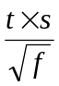=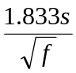.

Table 1 Average time from arrival of a job to its completion (second)
λ | 1 | 2 | 3 | 4 | 5 | 6 | 7 | 8 | 9 | 10
E(x) | 0.36 | 0.42 | 0.52 | 0.60 | 1.53 | 11.76 | 37.29 | 53.98 | 56.44 | 69.98
n | 300 | 612 | 858 | 1161 | 1495 | 1660 | 1606 | 1576 | 1663 | 1585
f | 299 | 611 | 857 | 1160 | 1494 | 1659 | 1605 | 1575 | 1662 | 1584
s | 0.38 | 0.49 | 0.55 | 0.56 | 1.24 | 8.41 | 21.95 | 30.31 | 32.32 | 42.30
δ | 0.04 | 0.04 | 0.03 | 0.03 | 0.06 | 0.38 | 1.00 | 1.40 | 1.45 | 1.95
Note: n is the number of jobs completed in the simulation time; λ means arrival rate; E(x) is sample mean; s is sample standard deviation; δ is half of the confidence interval.

Graph 1 Average time from arrival of a job to its completion
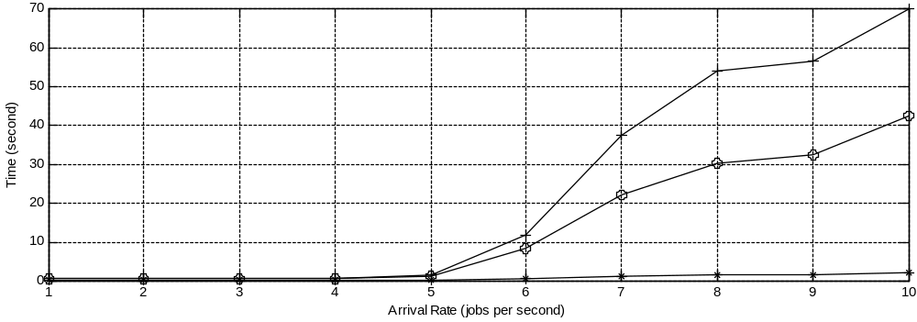
Note: the horizontal axis represents arrival rate λ; the vertical axis represents time (second); the curve with “+” denotes the mean of the samples; the one with “o” denotes the standard deviation s; the one with “*” denotes half of the confidence interval δ.

The analysis of E(x) with increasing λ: when λ ranges from 1 to 5, E(x) is around one second, increasing steadily and slightly, and the system is far from saturation, when jobs can be finished instantly; after λ reaches 6, E(x) increases dramatically, and the system approaches saturation; when λ is larger than 7, E(x)’s value is relatively large whose increasing rate goes back to normal, and the system is saturated.

Conclusion: λ=5~6 is a relatively proper arrival rate for this system, because jobs can be finished in a reasonable period of time while devices are fully utilized.

- Utilization of the devices

Utilization of the devices is shown in Table 2, with λ ranging from 1 to 10.

Table 2 Utilization of the devices
d λ | 1 | 2 | 3 | 4 | 5 | 6 | 7 | 8 | 9 | 10
CPU | 10.71% | 20.86% | 28.78% | 41.41% | 49.30% | 54.68% | 55.03% | 54.77% | 55.04% | 54.95%
Disk1 | 15.10% | 29.46% | 40.09% | 56.50% | 69.08% | 74.99% | 75.78% | 76.39% | 76.22% | 75.21%
Disk2 | 9.10% | 15.23% | 23.34% | 33.99% | 39.91% | 44.60% | 43.48% | 43.47% | 43.16% | 45.22%
Note: d represents different devices, including CPU, Disk1 (magnetic disk) and Disk2 (optical disk); λ means arrival rate.
Graph 2 Utilization of the devices
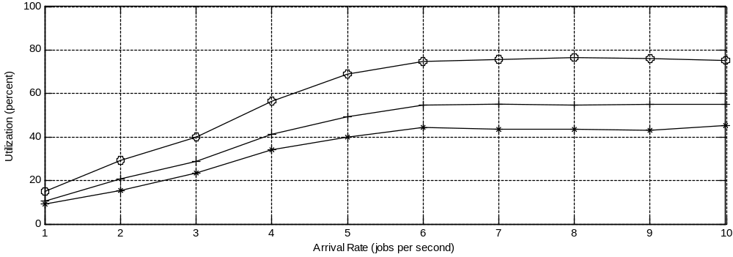

Note: the horizontal axis represents arrival rate λ; the vertical axis represents utilization (%); the curve with “+” denotes the utilization of CPU; the one with “o” denotes the utilization of Disk1; the one with “*” denotes the utilization of Disk2.

The analysis of utilization: for each of the three devices, when λ increases from 1 to 6, utilization increases steadily, but when λ becomes larger than 6, utilization remains relatively stable, less than 100%; for any λ, utilization of Disk1 is the largest, that of Disk2 smallest, and that of CPU medium.

Conclusions: first, after λ reaches 6, utilizations of the devices are less than 100%, but they do not increase any more, because memory is fully occupied and it restricts the performance of the system; second, utilization of Disk1 is always the largest one among these devices, so Disk1 is the bottleneck of the system.

- Average number of jobs queued for memory

The average number of jobs queued for memory is shown in row E(x) of Table 3, when λ ranges from 1 to 10. The analysis of error in mean with Student’s t test is the same as that of the first part.

Table 3 Average number of jobs queued for memory (jobs)
λ | 1 | 2 | 3 | 4 | 5 | 6 | 7 | 8 | 9 | 10
E(x) | 0.00 | 0.04 | 0.29 | 1.12 | 8.04 | 93.70 | 232.83 | 396.65 | 481.40 | 585.34
n | 5 | 89 | 480 | 975 | 2412 | 3409 | 3693 | 4056 | 4362 | 4749
f | 4 | 88 | 479 | 974 | 2411 | 3410 | 3692 | 4054 | 4363 | 4748
s | 0.08 | 0.33 | 1.01 | 2.20 | 7.81 | 52.65 | 139.69 | 234.19 | 263.40 | 373.17
δ | 0.07 | 0.06 | 0.10 | 0.13 | 0.28 | 1.65 | 4.25 | 6.78 | 7.31 | 9.99
Notes are the same as that of Table 1.

Graph 3 Average number of jobs queued for memory
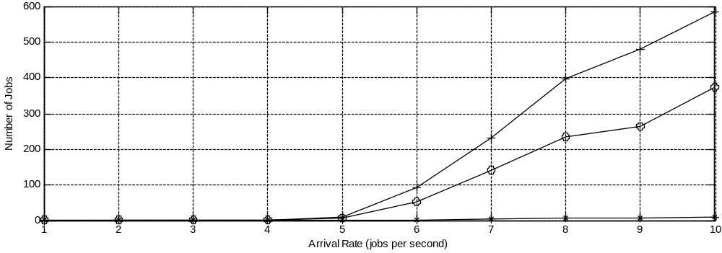
Note: the horizontal axis represents arrival rate λ; the vertical axis represents number of jobs; the curve with “+” denotes the mean of the samples; the one with “o” denotes the standard deviation s; the one with “*” denotes half of the confidence interval δ.

The analysis of E(x) with increasing λ: when λ ranges from 1 to 4, there is almost no job queuing for memory; when λ reaches 5, the number of jobs queuing for memory starts to increase dramatically; when λ is larger than 8, E(x) increases steadily, but the increasing rate is much less.

Conclusion: λ=5~6 is the proper arrival rate for this system, because the length of the queue of jobs waiting for memory is bearable while the memory is fully occupied.

Below is the histogram of the distribution of the number of jobs in memory queue with different λ.

Graph 4 Histogram of the distribution of the number of jobs in memory queue
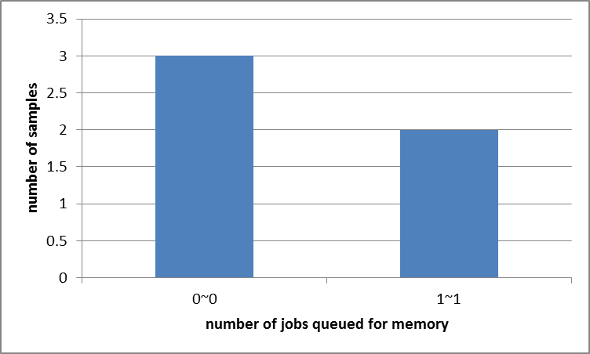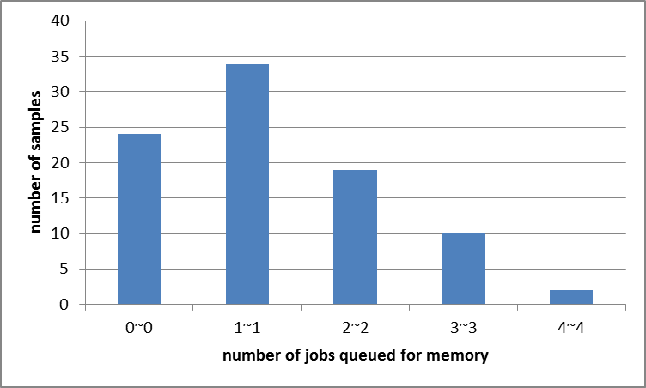
(a) λ=1 (b) λ=2
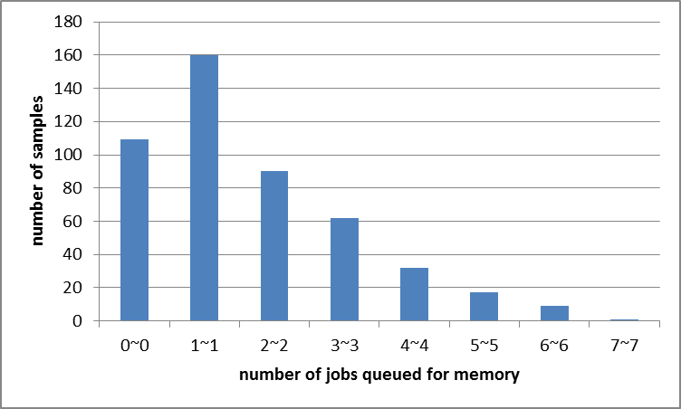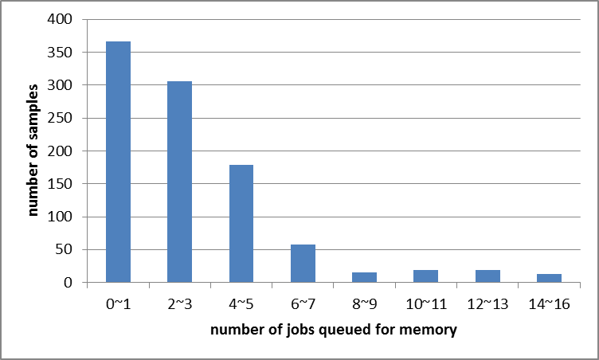
(c) λ=3 (d) λ=4
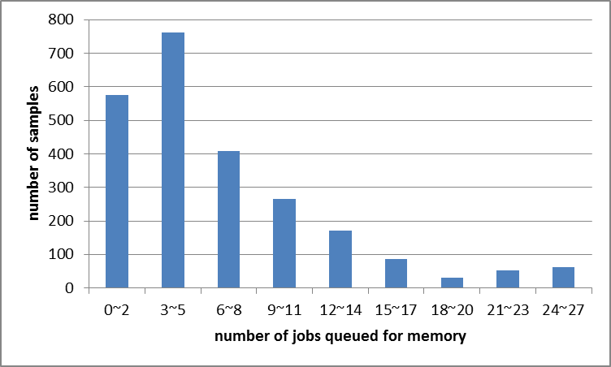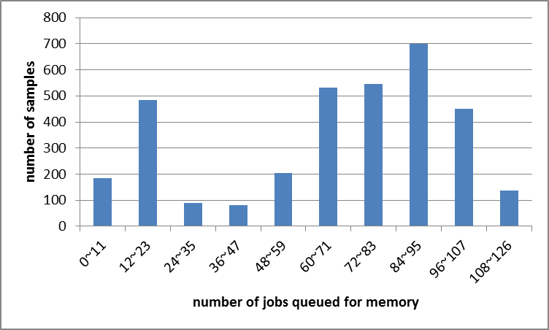
(e) λ=5 (f) λ=6
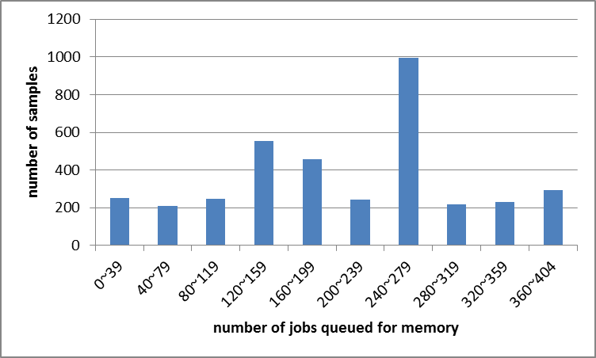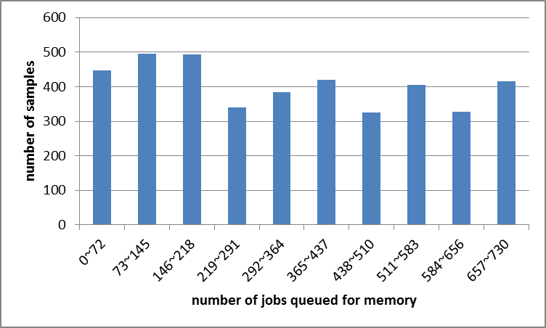
(g) λ=7 (h) λ=8
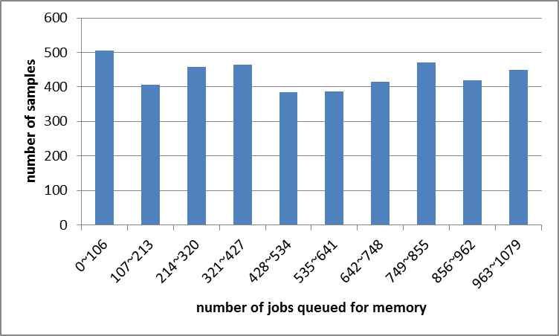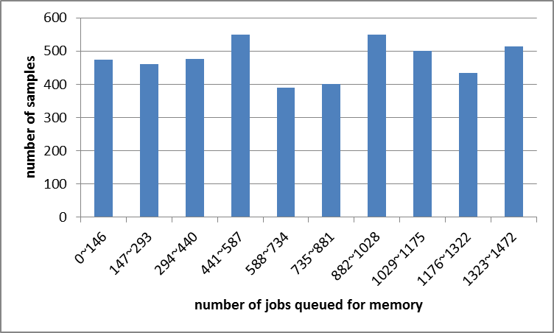
(i) λ=9 (j) λ=10

Note: the histograms only show the distribution of all the samples, but not the weight of them. Because each sample has a different duration, holding different impact on the expectation, the number of samples in a certain range does not necessarily mean the weight of them when calculation the expectation.

The analysis of the histograms: when λ≤5, the number of jobs in the memory queue is small (less than 10) in most samples, which means the system can easily handle this workload; when λ=6~7, the number of jobs in the memory queue distributes densely around a relatively high value among all the samples, which means the system is close to saturation; when λ≥8, the average number of jobs in the memory queue distributes quite uniformly, which means the length of the memory queue accumulates continuously and the system is overloaded.

Conclusion: λ=6~7 is the proper arrival rate for this system.

- Average number of jobs in the CPU and disks subsystem
As shown in Table 4, the average number of jobs in the CPU and disks subsystem is listed in row E(x), when λ ranges from 1 to 10. The analysis of error in mean with Student’s t test is the same as that of the first part.

Table 4 Average number of jobs in the CPU and disks subsystem (job)
λ | 1 | 2 | 3 | 4 | 5 | 6 | 7 | 8 | 9 | 10
E(x) | 0.35 | 0.83 | 1.48 | 1.98 | 2.79 | 2.92 | 2.99 | 2.99 | 3.00 | 3.00
n | 592 | 1184 | 1378 | 1296 | 360 | 140 | 20 | 18 | 10 | 6
f | 591 | 1183 | 1377 | 1295 | 359 | 139 | 19 | 17 | 9 | 5
s | 0.60 | 0.93 | 1.17 | 1.11 | 0.61 | 0.42 | 0.10 | 0.14 | 0.08 | 0.08
δ | 0.05 | 0.05 | 0.06 | 0.06 | 0.06 | 0.07 | 0.04 | 0.06 | 0.05 | 0.06
Notes are the same as that of Table 1.

Graph 5 Average number of jobs in the CPU and disks subsystem (job)
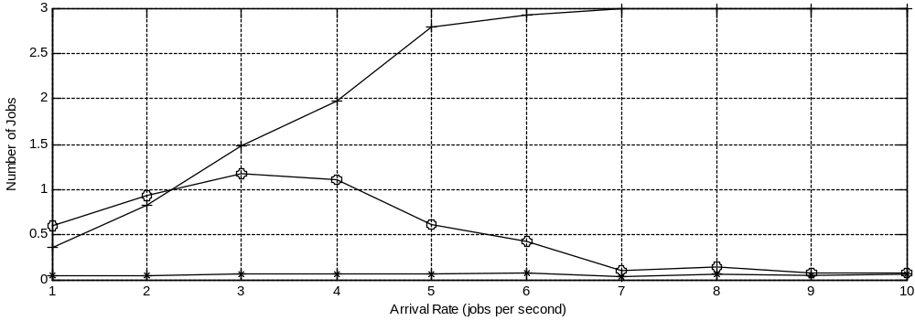
Note: the horizontal axis represents arrival rate λ; the vertical axis represents number; the curve with “+” denotes the mean of the samples; the one with “o” denotes the standard deviation s; the one with “*” denotes half of the confidence interval δ.

The analysis of average number of jobs in the CPU and disks subsystem with increasing λ: when λ ranges from 1 to 5, the number of jobs in the system increases steadily; after λ reaches 5, the number of jobs in the system begins to approach 3, which is the maximum number of jobs in the system; when λ is larger than 6, E(x) is almost equal to 3.

Conclusion: λ=5~6 is a relatively proper arrival rate for this system, because the memory is fully utilized while the system is not overloaded.

- Proper length of simulation time

The average number of jobs in the CPU and disks subsystem and its Standard deviation are used to evaluate whether the system has reached a stable state. Table 5 and Table 6 show the statistics with the simulation time ranging from 100s to 1000s. Graph 2 shows the number of jobs in the CPU and disks subsystem dynamically with the simulation time of 1000s.

Table 5 Average number of jobs in the CPU and disks subsystem
λ  t | 1 | 2 | 3 | 4 | 5 | 6 | 7 | 8 | 9 | 10
100 | 0.39 | 1.11 | 1.23 | 2.28 | 2.71 | 2.91 | 2.97 | 2.99 | 2.98 | 2.98
200 | 0.37 | 0.85 | 1.20 | 1.77 | 2.93 | 2.97 | 2.98 | 2.98 | 3.00 | 3.00
300 | 0.43 | 0.70 | 1.38 | 1.94 | 2.64 | 2.98 | 2.98 | 3.00 | 3.00 | 3.00
400 | 0.32 | 0.84 | 1.28 | 1.90 | 2.64 | 2.99 | 2.99 | 2.99 | 3.00 | 3.00
500 | 0.36 | 0.76 | 1.26 | 1.96 | 2.64 | 2.99 | 3.00 | 2.99 | 3.00 | 3.00
600 | 0.39 | 0.75 | 1.37 | 2.05 | 2.51 | 2.98 | 3.00 | 2.99 | 3.00 | 3.00
700 | 0.36 | 0.84 | 1.28 | 1.88 | 2.55 | 2.99 | 3.00 | 3.00 | 3.00 | 3.00
800 | 0.37 | 0.82 | 1.35 | 1.88 | 2.66 | 3.00 | 2.99 | 3.00 | 3.00 | 3.00
900 | 0.41 | 0.87 | 1.41 | 1.91 | 2.55 | 3.00 | 3.00 | 3.00 | 3.00 | 3.00
1000 | 0.38 | 0.82 | 1.25 | 1.95 | 2.66 | 3.00 | 3.00 | 3.00 | 3.00 | 3.00
Note: λ means arrival rate; t means simulation time.

Table 6 Standard deviation of average number of jobs in the CPU and disks subsystem
λ  t | 1 | 2 | 3 | 4 | 5 | 6 | 7 | 8 | 9 | 10
100 | 0.71 | 1.02 | 1.11 | 1.24 | 0.71 | 0.41 | 0.24 | 0.13 | 0.18 | 0.19
200 | 0.67 | 0.96 | 1.11 | 1.16 | 0.85 | 0.54 | 0.19 | 0.08 | 0.11 | 0.12
300 | 0.72 | 0.86 | 1.12 | 1.12 | 0.81 | 0.17 | 0.17 | 0.09 | 0.09 | 0.06
400 | 0.59 | 0.95 | 1.10 | 1.14 | 0.80 | 0.10 | 0.10 | 0.11 | 0.08 | 0.06
500 | 0.63 | 0.91 | 1.13 | 1.12 | 0.81 | 0.11 | 0.09 | 0.10 | 0.07 | 0.08
600 | 0.66 | 0.88 | 1.14 | 1.12 | 0.92 | 0.22 | 0.09 | 0.12 | 0.07 | 0.04
700 | 0.64 | 0.95 | 1.12 | 1.16 | 0.88 | 0.13 | 0.08 | 0.05 | 0.04 | 0.04
800 | 0.63 | 0.92 | 1.13 | 1.15 | 0.77 | 0.07 | 0.06 | 0.09 | 0.09 | 0.08
900 | 0.67 | 0.97 | 1.13 | 1.13 | 0.86 | 0.06 | 0.06 | 0.05 | 0.04 | 0.05
1000 | 0.65 | 0.95 | 1.10 | 1.14 | 0.79 | 0.08 | 0.04 | 0.05 | 0.06 | 0.05
Note: λ means arrival rate; t means simulation time.

Analysis about Table 5 and Table 6: for Table 5, when λ≤5, the average number of jobs in the CPU and disks subsystem basically stays stable with the simulation time larger than 200s; when λ>5, the system needs shorter time period (more than 100s) to reach the stable state, and the larger λ is , the less the time is. As for Table 6, when λ≤5, the standard deviation of the average number of jobs in the CPU and disks subsystem reaches a relatively small value with the simulation time larger than 200s; when λ>5, the standard deviation decreases with the increasing of the simulation time, but it is small enough from the beginning to determine that the system has reached a balanced state.

Conclusion: when λ≤5, 200s of simulation time is enough for the system to reach a balanced state; when λ>5, 100s of simulation time is enough.

Graph 6 Dynamic number of jobs in the CPU and disks subsystem
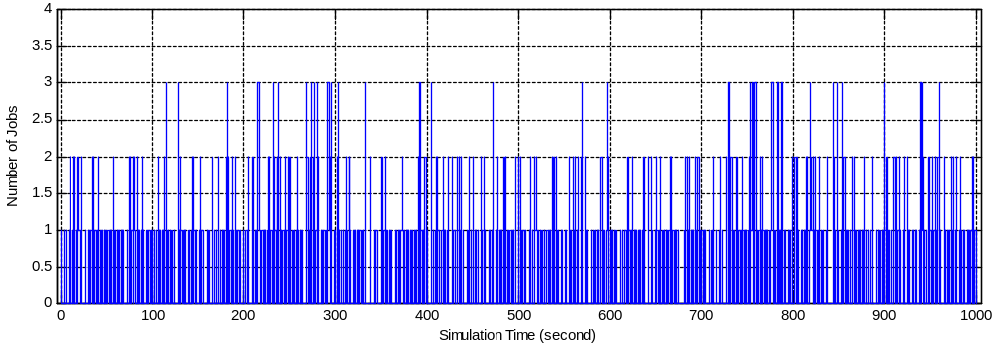
(a) λ=1
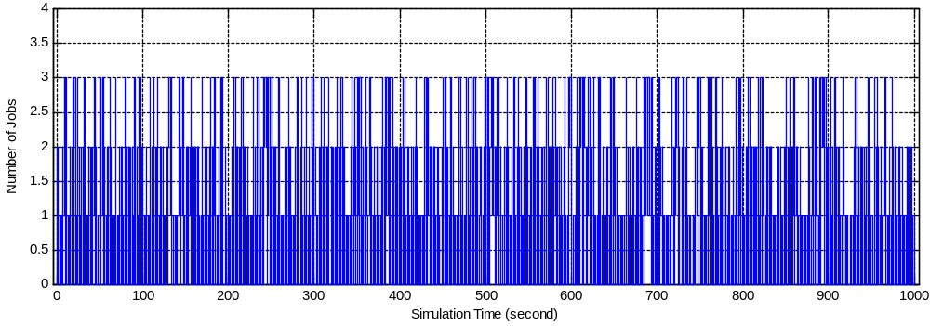
(b) λ=2
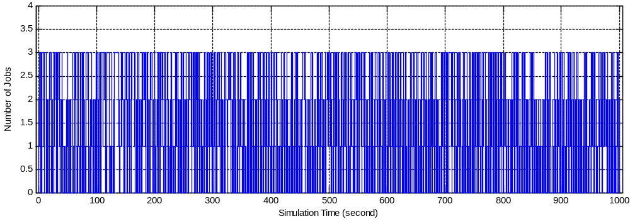
(c) λ=3
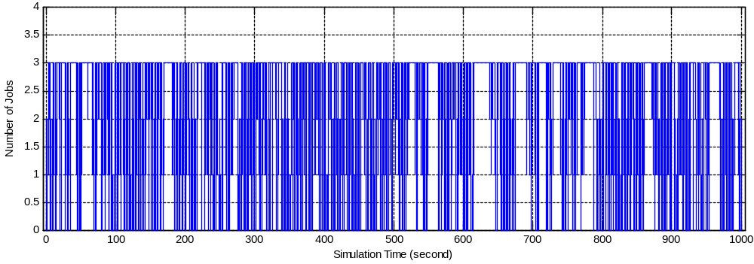
(d) λ=4
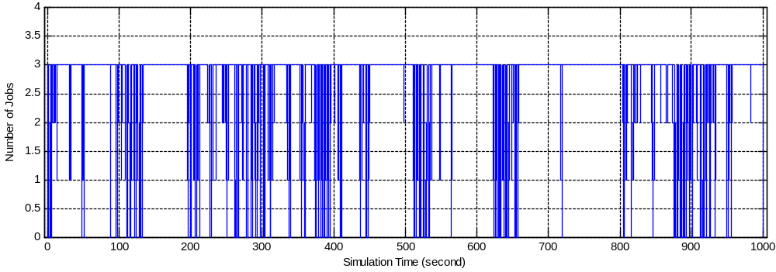
(e) λ=5
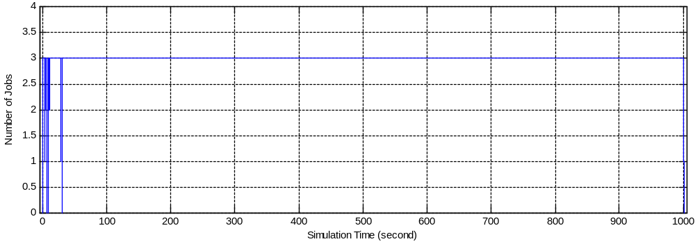
(f) λ=6
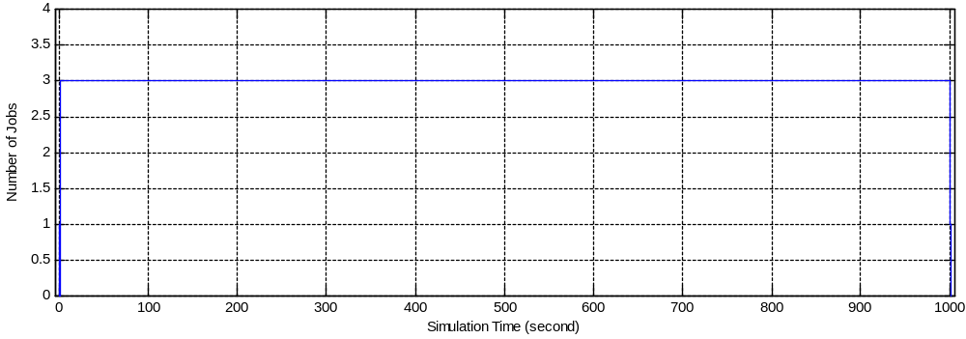
(g) λ=7
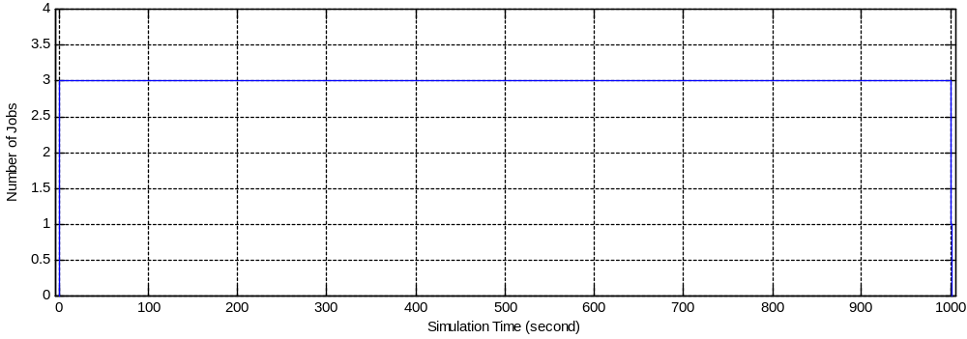
(h) λ=8
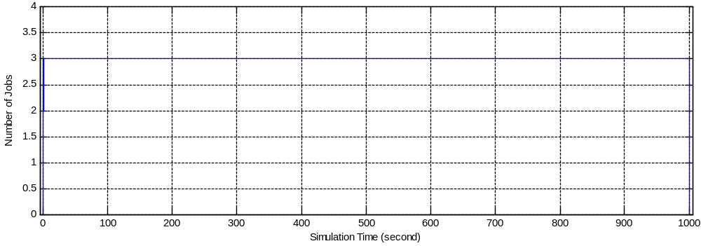
(i) λ=9
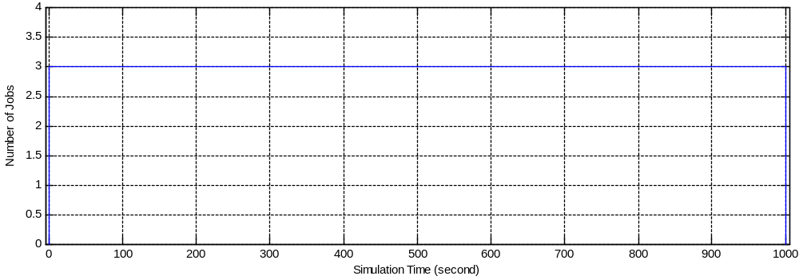
(j) λ=10

Analysis of Graph 6: when λ<6, after 100s of simulated time, the pattern of the diagram keeps unchanged; when λ≥6, after 50s of simulated time, the number of jobs in the system reaches 3 and remains unchanged, which is the maximum possible number of jobs.

Conclusion: when λ<6, the system needs at least 100s to establish a stable state; when λ≥6, the system needs at least 50s to establish a stable state.

Above all, the system needs 100~200s of simulation time to reach a stable state. Therefore, 300s of simulation time is enough and not too much, 200~300s is the proper length of simulation time.

- Memory expansion
If the memory is expanded to 2 Gbytes, while the sizes of the operating system and the jobs are unchanged, there will be 8 jobs at most in the system at any time.

With previous analysis in part 2, when λ is larger than 6, utilizations of the devices are less than 100%, but they do not increase any more. The only reason for this is that memory has been fully occupied and it restricts the performance of the system. Therefore, if the memory is expanded, utilizations of different devices will increase, and the system throughput will be increased consequently.

A good way to exam the conclusion above is to run the simulation with a memory of 1 Gbyte and 2 Gbytes respectively when λ=10, and calculate throughput (number of jobs completed per second) of the system during the simulation time. For each size of memory, we run the simulation for 300 seconds for 10 times, and the results are shown in Table 7.

Table 7 System throughput with different size of memory (jobs per second)
n  m | 1 | 2 | 3 | 4 | 5 | 6 | 7 | 8 | 9 | 10 | E(x)
1 G | 5.48 | 5.48 | 5.49 | 5.43 | 5.75 | 5.37 | 5.55 | 5.27 | 5.54 | 5.66 | 5.50
2 G | 7.10 | 6.66 | 6.52 | 6.93 | 6.99 | 7.14 | 6.74 | 6.87 | 6.75 | 6.65 | 6.83
Notes: n is the number of samples, and when n=1, it means the first sample; m is the size of memory; E(x) is the mean of 10 samples.

From the results, with a memory twice as large, the throughput of the system in the same period of time is 1.25 times of that with a 1 Gbyte memory. Therefore, the previous conclusion is proved correct. The system’s throughput will be increased if we add extra memory.

Table 8 Utilization of devices
n  m | 1 |  |  | 2 |  |  | 3 |  |  | E(x)
n  m | CPU | Disk1 | Disk2 | CPU | Disk1 | Disk2 | CPU | Disk1 | Disk2 | CPU | Disk1 | Disk2
1 G | 54.0% | 76.9% | 43.8% | 54.8% | 77.7% | 42.4% | 54.5% | 76.7% | 43.8% | 54.4% | 77.1% | 43.1%
2 G | 68.7% | 96.3% | 54.7% | 68.0% | 96.4% | 55.8% | 68.8% | 96.1% | 55.4% | 68.5% | 96.3% | 55.3%
Notes: n is the number of samples, and when n=1, it means the first sample; m is the size of memory; E(x) is the mean of 3 samples.

In addition, given the results of Table 8, it is obvious that the utilization of devices are enhanced by a larger memory. The utilizations of CPU, Disk1 and Disk2 are 1.26 times, 1.25 times and 1.28 times larger than before, respectively.

- CPU improvement
As the supplier suggested, we should replace the existing CPU with one twice as fast, as this will reduce the time to complete jobs as heavy loads.

In order to examine whether this method is helpful, we run the simulation for 10 times with a CPU whose service time is 0.01s and 0.005s respectively when λ=10. For each size of CPU, the simulation time is 300 seconds, and the results are shown in Table 9. The memory is still 1 Gbyte.

Table 9 Average time from arrival of a job to its completion (second)
n  t | 1 | 2 | 3 | 4 | 5 | 6 | 7 | 8 | 9 | 10 | E(x)
0.010 | 63.96 | 65.70 | 69.18 | 62.50 | 68.80 | 70.45 | 76.96 | 71.63 | 67.07 | 76.27 | 69.25
0.005 | 56.45 | 50.24 | 54.71 | 61.10 | 61.22 | 62.03 | 59.72 | 54.55 | 54.41 | 56.89 | 57.13
Notes: n is the number of samples, and when n=1, it means the first sample; t is the service time of the CPU; E(x) is the mean of 10 samples.

As shown in Table 9, the average time from arrival of a job to its completion is decreased with a CPU twice as fast. The time is reduced by 17.50%. So improving CPU is a useful way to enhance the system’s performance.

- Disk1 improvement

As discussed before, Disk1 is the bottleneck of the system, which is the key role in restricting the system’s performance among all the devices. Therefore, we would suggest improving Disk1 in order to get an obvious enhancement of the system.

We run the simulation for 10 times with a Disk1 whose service time is 0.02s and 0.01s respectively when λ=10. For each size of Disk1, the simulation time is 300 seconds, and the results are shown in Table 9. The memory is 2 Gbytes.

Table 10 Average time from arrival of a job to its completion (second)
n  t | 1 | 2 | 3 | 4 | 5 | 6 | 7 | 8 | 9 | 10 | E(x)
0.02 | 50.26 | 44.72 | 52.46 | 53.29 | 48.37 | 51.55 | 48.41 | 54.73 | 44.44 | 37.24 | 48.55
0.01 | 11.03 | 15.46 | 10.84 | 13.21 | 20.94 | 12.81 | 7.72 | 11.00 | 16.74 | 15.32 | 13.51
Notes: n is the number of samples, and when n=1, it means the first sample; t is the service time of the Disk1; E(x) is the mean of 10 samples.

As shown in Table 10, the average time from arrival of a job to its completion is decreased with a Disk1 twice as fast. The time is reduced by 72.17%, which means the system’s performance is improved enormously. Therefore, improving Disk1 is a better way to optimize the system than improving CPU. In fact, this is the most important device to enhance because it is the bottleneck of the system.

D. Summary of Recommendations

1. In order to increase the system’s throughput and the devices’ utilization, expansion of the main memory is an effective method. On the one hand, by enlarging the memory from 1 Gbyte to 2 Gbytes, the throughput of the system in 300 seconds of simulation is increased by 1.25 times. On the other hand, the utilizations of CPU, Disk1 and Disk2 are 1.26 times, 1.25 times and 1.28 times larger than before, respectively.

2. Improving each device including CPU, Disk1 and Disk2 would reduce the time to complete job as heavy loads, but the most efficient way is to improve the Disk1, because it is the bottleneck of the system. With a CPU twice as fast, the time is reduced by 17.50%. But with a Disk1 twice as fast, the time is reduced by 72.17%.

Appendix A: Program Code

- performance evaluation.cpp

#include "stdafx.h"
#include "stdlib.h"
#include "math.h"
#include "time.h"
#include "user_definition.h"
#include <iostream>
#include <iomanip>
#include <fstream>

using namespace std;

typedef int Flag;
typedef int Status;

Status Cpu_Status=IDLE;
Status Disk1_Status=IDLE;
Status Disk2_Status=IDLE;

float ct[5000], ctt[5000];//sample value and duration
int cnt=0;//sample number counter

typedef struct

{
float OccurTime;
float ReservedArrivalTime;
int NType;

}Event,ElemType;

typedef struct LNode

{
ElemType data;
LNode *next;

}*Link,*Position;

struct LinkList

{
Link head,tail;
int len; // length of the linklist
};

typedef LinkList EventList;

typedef struct

{
float ArrivalTime;
int Duration;

}QElemType; //element in a queue

typedef struct QNode

{
QElemType data;

QNode *next;

}*QueuePtr;

struct LinkQueue

{
QueuePtr front,rear;
};

EventList ev;

Event en;

Event et;//temporary variable

LinkQueue Q_CPU;
LinkQueue Q_memory;
LinkQueue Q_disk1;
LinkQueue Q_disk2;
QElemType temp_record; //customer's record

/*important user's variables*/
long long holdrand[5];
int current_job_number=0;
float total_Cpu_time=0;
float total_Disk1_time=0;
float total_Disk2_time=0;
int arrival_lambda=1;
int simulated_time;
Flag end_flag=FALSE;
int finished_number=0;
float total_finished_time=0;

float average_memory_queue=0.0;
float total_memory_queue=0;
float previous_operating_memory_time=0.0;

float average_job=0.0;
float total_job=0.0;
float previous_operating_job_time=0.0;

float final_CPU_event_time = 0.0;
float final_disk1_event_time = 0.0;
float final_disk2_event_time =0.0;

float current_CPU_utilization;
float current_disk1_utilization;
float current_disk2_utilization;

streambuf *backup , *psbuf;
ofstream filestr;
char *filename;

void Start_Redirect(void)
{
backup = std::cout.rdbuf();

filestr.open(filename);

psbuf = filestr.rdbuf();

std::cout.rdbuf(psbuf);
}

void Close_Redirect(void)
{
filestr.close();

std::cout.rdbuf(backup);

}

//Type's value is ARRIVAL_TYPE, CPU_TYPE, DISK1_TYPE, DISK2_TYPE, CPU_PUT 4, respectively
int __cdecl random(int Type)
{
return (((holdrand[Type] = holdrand[Type] * 214013L + 2531011L) >> 16) & 0x7fff);
}

//Poisson returns time interval. lambda denotes arrival rate
//Type's value is ARRIVAL_TYPE, CPU_TYPE, DISK1_TYPE, DISK2_TYPE
float Poisson(float lambda,int Type)
{
float z;
do
{ z = ((float)random(Type))/RAND_MAX;
}while(z == 0 || z == 1);
return (-(1/lambda)*log(1-z));
}

int cmp(Event a,Event b)

{ // compare occuring time of events a and b, return -1, 0 or 1

if(a.OccurTime==b.OccurTime)

return 0;

else if(a.OccurTime<b.OccurTime)

return -1;
else

return 1;

}

Status InitList(LinkList &L)

{ // create an empty event list

Link p;

p=(Link)malloc(sizeof(LNode)); // generate the head node

if(p)

{

p->next=NULL;

L.head=L.tail=p;

L.len=0;

return OK;

}

else

return ERROR;

}//InitList

Status ClearList ( LinkList &L )
{
Link p;

while(L.head->next)
{
p=L.head->next;

L.head->next=p->next;
free(p);
}

L.tail=L.head;

L.len=0;

return OK;
}

Status InitQueue(LinkQueue &Q)

{ // initiate an empty queue Q
if(!(Q.front=Q.rear=(QueuePtr)malloc(sizeof(QNode))))

exit(-1);

Q.front->next=NULL;

return OK;

}//InitQueue

Status ClearQueue(LinkQueue &Q)
{
if(Q.front->next== NULL)
return OK;
QueuePtr s = Q.front->next,p;
while(s)
{
p=s->next;
free(s);
s = p;
}
Q.rear = Q.front;
Q.front->next=NULL;
return OK;
}
Status OrderInsert(LinkList &L,ElemType e,int (*comp)(ElemType,ElemType))

{ // Insert element e into a linklist L

Link o,p,q;

q=L.head;

p=q->next;

while(p!=NULL&&comp(p->data,e)<0) // p is not the tail and element is less than e

{

q=p;

p=p->next;

}

o=(Link)malloc(sizeof(LNode)); // create a node

o->data=e; // assignment

q->next=o; // insertion

o->next=p;

L.len++; // linklist's length increases by one

if(!p) // insert an element to the tail

L.tail=o; // change the tail node

return OK;

}//OrderInsert

/*
Flag CPU_Random(void)
According to CPU output event's possibility distribution, return TO_DISK1，ê?TO_DISK2，ê?LEAVE
*/
Flag CPU_Random(void)
{
int rand_num;
rand_num=random(CPU_PUT)%10+1;//generate a random number between 1 and 10
if(rand_num<=7)
return TO_DISK1;
else if(rand_num>7&&rand_num<10)
return TO_DISK2;
else
return LEAVE;
}//CPU_Random

int QueueLength(LinkQueue Q)

{ // calculate the length of queue Q

int i=0;

QueuePtr p;

p=Q.front;

while(Q.rear!=p)

{

i++;

p=p->next;

}

return i;

}//QueueLength

Status EnQueue(LinkQueue &Q,QElemType e)

{ // insert e to the tail of queue Q

QueuePtr p;

if(!(p=(QueuePtr)malloc(sizeof(QNode)))) // memory allocation fails
exit(OVERFLOW);

p->data=e;

p->next=NULL;

Q.rear->next=p;

Q.rear=p;

return OK;

}//EnQueue

Status DeQueue(LinkQueue &Q,QElemType &e)

{ // if queue is not empty, delete the head, return it with e, and returnOK; otherwise return ERROR and the head dequeues

QueuePtr p;

if(Q.front==Q.rear)

return ERROR;

p=Q.front->next;

e=p->data;

Q.front->next=p->next;

if(Q.rear==p)

Q.rear=Q.front;

free(p);

return OK;

}//DeQueue

Status GetHead(LinkQueue Q,QElemType &e)

{

QueuePtr p;

if(Q.front==Q.rear)

return ERROR;

p=Q.front->next;

e=p->data;

return OK;

}//GetHead

Position GetHead(LinkList L)

{
return L.head;

}//GetHead

Status QueueEmpty(LinkQueue Q)

{ // if Q is empty, return true; otherwise, return false

if(Q.front==Q.rear)

return TRUE;

else

return FALSE;

}//QueueEmpty

Status ListEmpty(LinkList L)

{
if(L.len)

return FALSE;

else

return TRUE;

}//ListEmpty

Status DelFirst(LinkList &L,Link h,Link &q)

{
q=h->next;

if(q)

{

h->next=q->next;

if(!h->next)

L.tail=h;

// cout<<L.len<<endl;

L.len--;

return OK;

}

else

return FALSE;

}//DelFirst

ElemType GetCurElem(Link p)

{
return p->data;

}//GetCurElem

void Re_initialization()

{
ClearList(ev);

en.OccurTime=0;

en.ReservedArrivalTime=0;

en.NType=0;

OrderInsert(ev,en,cmp);//insert the first arrival event

ClearQueue(Q_CPU);

ClearQueue(Q_memory);

ClearQueue(Q_disk1);

ClearQueue(Q_disk2);

Cpu_Status=IDLE;
Disk1_Status=IDLE;
Disk2_Status=IDLE;

current_job_number=0;

end_flag=FALSE;

total_Cpu_time=0;
total_Disk1_time=0;
total_Disk2_time=0;
finished_number=0;
total_finished_time=0;
average_memory_queue=0.0;
total_memory_queue=0;
previous_operating_memory_time=0.0;
average_job=0.0;
total_job=0.0;
previous_operating_job_time=0.0;
final_CPU_event_time = 0.0;
final_disk1_event_time = 0.0;
final_disk2_event_time =0.0;
current_CPU_utilization = 0.0;
current_disk1_utilization = 0.0;
current_disk2_utilization = 0.0;

}//Reinitialization
void Initialization()

{
InitList(ev); //initiate event list

en.OccurTime=0;

en.ReservedArrivalTime=0;

en.NType=0;

OrderInsert(ev,en,cmp);

InitQueue(Q_CPU);

InitQueue(Q_memory);

InitQueue(Q_disk1);

InitQueue(Q_disk2);

holdrand[0]=time(NULL);
holdrand[1]=holdrand[0]+1;
holdrand[2]=holdrand[1]+1;
holdrand[3]=holdrand[2]+1;
holdrand[4]=holdrand[3]+1;

Cpu_Status=IDLE;
Disk1_Status=IDLE;
Disk2_Status=IDLE;

current_job_number=0;

end_flag=FALSE;

total_Cpu_time=0;
total_Disk1_time=0;
total_Disk2_time=0;
finished_number=0;
total_finished_time=0;
average_memory_queue=0.0;
total_memory_queue=0;
previous_operating_memory_time=0.0;
average_job=0.0;
total_job=0.0;
previous_operating_job_time=0.0;
final_CPU_event_time = 0.0;
final_disk1_event_time = 0.0;
final_disk2_event_time =0.0;
current_CPU_utilization = 0.0;
current_disk1_utilization = 0.0;
current_disk2_utilization = 0.0;

}//Initialization

void Arrival(void)
{
QElemType f;

float intertime=0;
intertime=Poisson(arrival_lambda,ARRIVAL_TYPE);

et.OccurTime=en.OccurTime+intertime;

et.ReservedArrivalTime=et.OccurTime;

et.NType=JOB_ARRIVAL;

OrderInsert(ev,et,cmp);

if(current_job_number<MAX_JOB_NUMBER)//there is space in memory
{
total_job += current_job_number*(en.OccurTime-previous_operating_job_time);

ct[cnt]=current_job_number;
ctt[cnt]=en.OccurTime-previous_operating_job_time;
cnt++;

previous_operating_job_time = en.OccurTime;

current_job_number++;

if(Cpu_Status==IDLE)
{
Cpu_Status=BUSY;
intertime=Poisson(CPU_LAMBDA,CPU_TYPE);

total_Cpu_time +=intertime;

et.OccurTime=en.OccurTime+intertime;

et.ReservedArrivalTime=en.ReservedArrivalTime;

et.NType=END_PROCESSING;

OrderInsert(ev,et,cmp);
}

else//CPU is BUSY
{
f.ArrivalTime=en.ReservedArrivalTime;

f.Duration=NULL;

EnQueue(Q_CPU,f);
}
}

else//memory is stuffed
{
f.ArrivalTime=en.ReservedArrivalTime;

f.Duration=NULL;
// cout<<en.OccurTime<<"\t"<<QueueLength(Q_memory)<<endl;

total_memory_queue += QueueLength(Q_memory)*(en.OccurTime-previous_operating_memory_time);

//ct[cnt]=QueueLength(Q_memory);
//ctt[cnt]=en.OccurTime-previous_operating_memory_time;

//cnt++;

previous_operating_memory_time = en.OccurTime;

EnQueue(Q_memory,f);

//cout<<en.OccurTime<<"\t"<<QueueLength(Q_memory)<<endl;
}
}
/**
This function process the leaving of an event.
It examines whether the memory queue is empty, first; then if the queue is not empty, dequeue the queue's head,
and insert it to CPU queue; if not, release memory, increase the number of current jobs by one.
***/
void Leave(void)
{
QElemType f;

//ct[finished_number]=en.OccurTime-en.ReservedArrivalTime;

finished_number++;//finished_number
total_finished_time += en.OccurTime-en.ReservedArrivalTime; //
cout<<finished_number
<<"\t"<< en.ReservedArrivalTime
<<"\t"<< en.OccurTime
<<"\t"<< en.OccurTime-en.ReservedArrivalTime<<endl; //
if(!QueueEmpty(Q_memory)&&!end_flag)// {
//cout<<en.OccurTime<<"\t"<<QueueLength(Q_memory)<<endl;//
total_memory_queue += QueueLength(Q_memory)*(en.OccurTime-previous_operating_memory_time);//
//ct[cnt]=QueueLength(Q_memory); //ctt[cnt]=en.OccurTime-previous_operating_memory_time;

//cnt++;

previous_operating_memory_time = en.OccurTime;

DeQueue(Q_memory,temp_record);

//cout<<en.OccurTime<<"\t"<<QueueLength(Q_memory)<<endl;//
f.ArrivalTime=temp_record.ArrivalTime;

f.Duration=NULL;

EnQueue(Q_CPU,f);
}
else
{
total_job += current_job_number*(en.OccurTime-previous_operating_job_time);
ct[cnt]=current_job_number;
ctt[cnt]=en.OccurTime-previous_operating_job_time;
cnt++;

previous_operating_job_time = en.OccurTime;
current_job_number--;
}
}
void ToDisk1(void)
{
QElemType f;

float intertime=0;

if(Disk1_Status==IDLE)//
{
Disk1_Status=BUSY;
intertime=Poisson(DISK1_LAMBDA,DISK1_TYPE);
total_Disk1_time+=intertime;

et.OccurTime=en.OccurTime+intertime;
et.ReservedArrivalTime=en.ReservedArrivalTime;

et.NType=END_DISK1;

OrderInsert(ev,et,cmp);

}

else
{
f.ArrivalTime=en.ReservedArrivalTime;

f.Duration=NULL;

EnQueue(Q_disk1,f);
}
}

void ToDisk2(void)
{
QElemType f;

float intertime=0;

if(Disk2_Status==IDLE)
{
Disk2_Status=BUSY;
intertime=Poisson(DISK2_LAMBDA,DISK2_TYPE);

total_Disk2_time+=intertime;

et.OccurTime=en.OccurTime+intertime;
et.ReservedArrivalTime=en.ReservedArrivalTime;

et.NType=END_DISK2;

OrderInsert(ev,et,cmp);
}

else
{
f.ArrivalTime=en.ReservedArrivalTime;

f.Duration=NULL;

EnQueue(Q_disk2,f);
}
}

void End_Processing(void)
{
float intertime=0;

final_CPU_event_time = en.OccurTime;

if(final_CPU_event_time != 0)
{
current_CPU_utilization = total_Cpu_time/final_CPU_event_time;
}

switch(CPU_Random())
{
case LEAVE: Leave();break;
case TO_DISK2: ToDisk2();break;
case TO_DISK1: ToDisk1();break;
default:break;
}

if(!QueueEmpty(Q_CPU))
{
DeQueue(Q_CPU,temp_record);
Cpu_Status=BUSY;
intertime=Poisson(CPU_LAMBDA,CPU_TYPE);
total_Cpu_time +=intertime;

et.OccurTime=en.OccurTime+intertime;
et.ReservedArrivalTime=temp_record.ArrivalTime;

et.NType=END_PROCESSING;
OrderInsert(ev,et,cmp);
}
else
{
Cpu_Status=IDLE;
}
}

void End_Disk1(void)
{
float intertime=0;

final_disk1_event_time = en.OccurTime;

if(final_disk1_event_time != 0)
{
current_disk1_utilization = total_Disk1_time/final_disk1_event_time;
}
QElemType f;

if(Cpu_Status==IDLE)
{
Cpu_Status=BUSY;

intertime=Poisson(CPU_LAMBDA,CPU_TYPE);
total_Cpu_time +=intertime;

et.OccurTime=en.OccurTime+intertime;

et.ReservedArrivalTime=en.ReservedArrivalTime;

et.NType=END_PROCESSING;

OrderInsert(ev,et,cmp);
}
else
{
f.ArrivalTime=en.ReservedArrivalTime;

f.Duration=NULL;

EnQueue(Q_CPU,f);
}

if(!QueueEmpty(Q_disk1))
{
DeQueue(Q_disk1,temp_record);

Disk1_Status=BUSY;
intertime=Poisson(DISK1_LAMBDA,DISK1_TYPE);

total_Disk1_time+=intertime;

et.OccurTime=en.OccurTime+intertime;
et.ReservedArrivalTime=temp_record.ArrivalTime;

et.NType=END_DISK1;

OrderInsert(ev,et,cmp);
}
else
{
Disk1_Status=IDLE;
}
}

void End_Disk2(void)
{
float intertime=0;

final_disk2_event_time = en.OccurTime;

if(final_disk2_event_time != 0)
{
current_disk2_utilization = total_Disk2_time/final_disk2_event_time;
}

QElemType f;

if(Cpu_Status==IDLE)
{
Cpu_Status=BUSY;
intertime=Poisson(CPU_LAMBDA,CPU_TYPE);

total_Cpu_time +=intertime;

et.OccurTime=en.OccurTime+intertime;
et.ReservedArrivalTime=en.ReservedArrivalTime;
et.NType=END_PROCESSING;

OrderInsert(ev,et,cmp);
}
else
{
f.ArrivalTime=en.ReservedArrivalTime;

f.Duration=NULL;

EnQueue(Q_CPU,f);
}

if(!QueueEmpty(Q_disk2))
{
DeQueue(Q_disk2,temp_record);

Disk2_Status=BUSY;
intertime=Poisson(DISK2_LAMBDA,DISK2_TYPE);

total_Disk2_time+=intertime;

et.OccurTime=en.OccurTime+intertime;
et.ReservedArrivalTime=temp_record.ArrivalTime;

et.NType=END_DISK2;

OrderInsert(ev,et,cmp);
}
else
{
Disk2_Status=IDLE;
}
}

void Computer_System_Simulation()

{
Link p;

cout<<fixed;

cout<<setprecision(6);

while(!ListEmpty(ev))

{
DelFirst(ev,GetHead(ev),p);
en.OccurTime=GetCurElem(p).OccurTime;

en.ReservedArrivalTime=GetCurElem(p).ReservedArrivalTime;

en.NType=GetCurElem(p).NType;

if(en.OccurTime >simulated_time && end_flag == FALSE )
{
total_memory_queue += QueueLength(Q_memory)*(simulated_time-previous_operating_memory_time);

//ct[cnt]=QueueLength(Q_memory);
//ctt[cnt]=simulated_time-previous_operating_memory_time;
//cnt++;

end_flag=TRUE;
}

switch(en.NType)
{
case JOB_ARRIVAL:
if( end_flag==FALSE)
{
Arrival();
}
break;
case END_PROCESSING: End_Processing();break;
case END_DISK1: End_Disk1();break;
case END_DISK2: End_Disk2();break;
default:break;
}
}//while

}//Computer_System_Simulation

int main()
{
Initialization();

cout <<"Please input system simulated time : ";
cin>>simulated_time;

cout<<"when the maximum job number is "<<MAX_JOB_NUMBER
<<" and the simulated time is "<<simulated_time
<<"s,the result:\n\n";

cout<<setw(40)<<"Total"<<setw(9)<<"Average"<<setw(9)<<"Average"<<setw(9)<<"Average"<<setw(12)<<"Utilization"<<endl;

cout<<setw(6)<<"lambda"
<<setw(5)<<" CPU"
<<setw(11)<<" DISK1"
<<setw(9)<<" DISK2"
<<setw(9)<<"finished"
<<setw(9)<<"finished"
<<setw(9)<<"memory"
<<setw(9)<<"job"
<<setw(12)<<"of "<<endl;

cout<<setw(40)<<"number"<<setw(9)<<"time"<<setw(9)<<"queue"<<setw(9)<<"number"<<setw(12)<<"memory "<<endl;

char str1[10][15]={"arrival_1.txt","arrival_2.txt","arrival_3.txt","arrival_4.txt",
"arrival_5.txt","arrival_6.txt","arrival_7.txt","arrival_8.txt",
"arrival_9.txt","arrival_10.txt"};

char str2[10][15]={"arrival_1.xls","arrival_2.xls","arrival_3.xls","arrival_4.xls",
"arrival_5.xls","arrival_6.xls","arrival_7.xls","arrival_8.xls",
"arrival_9.xls","arrival_10.xls"};
filename=&str1[0][0];

float mct, sum;

int i;

for(arrival_lambda=1;arrival_lambda<=10;arrival_lambda++)
{

Start_Redirect();

cnt=0;

Computer_System_Simulation();

Close_Redirect();

filename +=15;

average_memory_queue = total_memory_queue/simulated_time;

average_job = total_job/previous_operating_job_time;

//mct=total_finished_time/finished_number;

sum=0;

cout<<setw(4)<<fixed<<arrival_lambda<<setprecision(2)<<" "
<<setw(8)<<total_Cpu_time/final_CPU_event_time*100<<"%"<<" "
<<setw(8)<<total_Disk1_time/final_disk1_event_time*100<<"%"<<" "
<<setw(8)<<total_Disk2_time/final_disk2_event_time*100<<"%"<<" "<<endl;
<<setw(9)<<finished_number<<" "
//<<setw(9)<<total_finished_time/finished_number<<" "<<endl; //<<setw(9)<<average_memory_queue<<" ";
//<<setw(9)<<setprecision(4)<<average_job<<" "; //<<setw(9)<<setprecision(2)<<average_job/MAX_JOB_NUMBER*100<<"%"<<endl;

/* for (i=0; i<cnt; i++)
{
//sum+=pow(abs(ct[i]-mct), 2)/finished_number;
sum+=pow(abs(ct[i]-average_job), 2)*ctt[i]/previous_operating_job_time;
}
sum=sqrt(sum);

cout<<cnt<<" "<<cnt-1<<" ";

cout<<sum<<" "<<1.833*sum/sqrt(double(cnt-1))<<endl; */

Re_initialization();

}
cin.get();
cin.get();
return 0;
}

2. user_definition.h

// NType
#define JOB_ARRIVAL 0
#define END_PROCESSING 1
#define END_DISK1 2
#define END_DISK2 3

#define MAX_JOB_NUMBER 8//
#define SIMULATED_TIME 300 //

#define OK 1

#define ERROR 0

#define TRUE 1

#define FALSE 0

#define LEAVE 2
#define TO_DISK2 1
#define TO_DISK1 0

//Lambda
#define ARRIVAL_LAMBDA 10//
#define CPU_LAMBDA 100//
#define DISK1_LAMBDA 50//
#define DISK2_LAMBDA 25

//Type of random() and poisson()
#define ARRIVAL_TYPE 0
#define CPU_TYPE 1
#define DISK1_TYPE 2
#define DISK2_TYPE 3
#define CPU_PUT 4

#define BUSY 1
#define IDLE 0

Appendix B: Output Samples

1. Please input system simulated time: when the maximum job number is 3 and the simulated time is 300s, the result:

Total Average Average Average Utilization
lambda CPU DISK1 DISK2 finished finished memory job of
number time queue number memory
1 10.78% 14.94% 8.67% 310 0.37 0.00 0.3820 12.73%
2 19.69% 26.37% 14.92% 577 0.41 0.03 0.7523 25.08%
3 29.27% 41.35% 23.97% 894 0.50 0.18 1.2941 43.14%
4 39.59% 56.62% 31.95% 1176 0.92 1.62 1.9798 65.99%
5 47.46% 67.24% 37.45% 1427 1.49 4.60 2.4809 82.70%
6 54.16% 76.56% 43.16% 1665 11.39 61.21 2.9808 99.36%
7 54.58% 75.38% 45.75% 1615 35.47 241.55 2.9954 99.85%
8 55.14% 75.59% 43.46% 1646 48.97 381.15 2.9853 99.51%
9 54.15% 75.74% 44.34% 1683 51.28 453.05 2.9911 99.70%
10 54.97% 77.28% 44.08% 1660 70.94 705.87 2.9977 99.92%

2. Please input system simulated time: when the maximum job number is 3 and the simulated time is 1000s, the result:

Total Average Average Average Utilization
lambda CPU DISK1 DISK2 finished finished memory job of
number time queue number memory
1 9.98% 13.72% 8.01% 996 0.35 0.00 0.3507 11.69%
2 20.30% 28.59% 16.79% 1951 0.45 0.04 0.8357 27.86%
3 29.29% 40.75% 22.84% 2994 0.50 0.21 1.2902 43.01%
4 40.24% 56.23% 33.47% 3994 0.80 1.22 1.9814 66.05%
5 49.31% 69.11% 39.14% 4949 1.67 5.67 2.5972 86.57%
6 54.81% 76.55% 44.18% 5473 53.46 318.67 2.9973 99.91%
7 54.78% 77.06% 43.12% 5551 97.89 689.88 2.9968 99.89%
8 54.85% 77.27% 42.52% 5565 156.96 1219.12 2.9966 99.89%
9 54.68% 76.45% 43.96% 5475 186.38 1665.58 2.9973 99.91%
10 54.50% 77.34% 43.51% 5402 221.91 2173.11 2.9993 99.98%

3. Please input system simulated time: when the maximum job number is 8 and the simulated time is 1000s, the result:

Total Average Average Average Utilization
lambda CPU DISK1 DISK2 finished finished memory job of
number time queue number memory
1 9.80% 13.78% 7.99% 955 0.37 0.00 0.3537 4.42%
2 18.75% 26.04% 15.23% 1906 0.40 0.00 0.7550 9.44%
3 29.01% 40.76% 24.21% 2979 0.47 0.01 1.3979 17.47%
4 40.00% 56.18% 32.50% 3988 0.60 0.07 2.3105 28.88%
5 50.80% 70.97% 40.32% 4955 0.87 0.52 3.7880 47.35%
6 58.95% 82.92% 47.35% 6006 1.35 2.68 5.4155 67.69%
7 67.06% 95.23% 53.17% 6863 6.81 39.18 7.8101 97.63%
8 68.28% 95.67% 54.92% 6789 85.46 668.48 7.9542 99.43%
9 68.46% 96.31% 53.38% 6833 133.12 1164.46 7.9861 99.83%
10 68.54% 95.96% 54.79% 7033 152.09 1487.85 7.9910 99.89%

4. Please input system simulated time: when the maximum job number is 8 and the simulated time is 500s, the result:

Total Average Average Average Utilization
lambda CPU DISK1 DISK2 finished finished memory job of
number time queue number memory
1 9.42% 13.05% 8.01% 473 0.36 0.00 0.3373 4.22%
2 19.22% 27.16% 16.42% 1017 0.38 0.00 0.7724 9.65%
3 30.49% 42.15% 23.84% 1491 0.47 0.00 1.4093 17.62%
4 40.43% 57.31% 32.78% 2006 0.62 0.02 2.4589 30.74%
5 51.26% 73.31% 40.18% 2523 1.17 1.80 4.0837 51.05%
6 59.73% 81.36% 47.82% 2970 1.26 2.18 5.2861 66.08%
7 68.23% 94.91% 55.07% 3441 4.94 26.28 7.7357 96.70%
8 68.31% 96.18% 53.28% 3461 29.38 225.93 7.9662 99.58%
9 67.56% 96.47% 54.37% 3366 61.54 531.28 7.9702 99.63%
10 68.36% 95.88% 53.70% 3502 72.24 724.00 7.9823 99.78%

